Year 9 |  | Ratio and Rates | Non Calculator
Skills and Knowledge Assessed:  - Solve a range of problems involving rates and ratios, with and without digital technologies (ACMNA188) |  |  | Name_________________
Section 1 Short Answer Section
Write all working and answers in the spaces provided on this test paper.

There are 15 aeroplanes and 4 helicopters at an airfield waiting to take off.
What is the ratio of helicopters to aeroplanes?

……………………………………………………………………………………………….
Simplify the ratio 20 : 35.

……………………………………………………………………………………………….

……………………………………………………………………………………………….
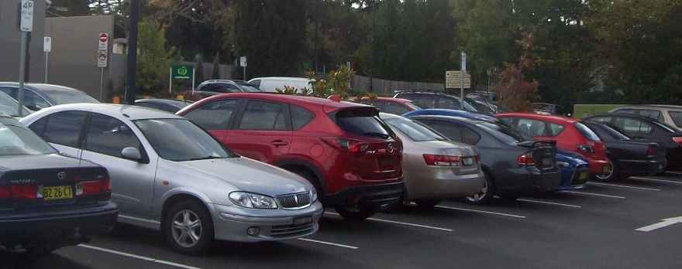
There are 40 sedans and 24 hatchbacks in a car park. What is the ratio of sedans to hatch backs in simplest form?

…………………………………………

…………………………………………

…………………………………………
Divide $200 between John and Paul in the ratio 3 : 2.

……………………………………………………………………………………………….

……………………………………………………………………………………………….
On a recent afternoon, a heavy vehicle checkpoint was visited by trucks and buses in the ratio 15 : 4. There were 80 buses. How many trucks were there?

……………………………………………………………………………………………….

……………………………………………………………………………………………….
Mike walks 250 m in 50 seconds.
What is his speed in m/s?

……………………………………………………………………………………………….

……………………………………………………………………………………………….
Simplify the ratio 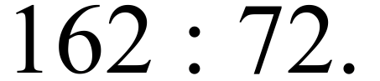

……………………………………………………………………………………………….

…………………………………… ………………………………………………………….
A survey finds that the ratio of open space to buildings in a city is 3 : 17.
What fraction of the city is open space?

……………………………………………………………………………………………….

……………………………………………………………………………………………….
There were 350 customers in the Sports Energy store last week. The ratio of males to females was 4 : 3 respectively. How many males were there?

……………………………………………………………………………………………….

……………………………………………………………………………………………….
Simplify the ratio 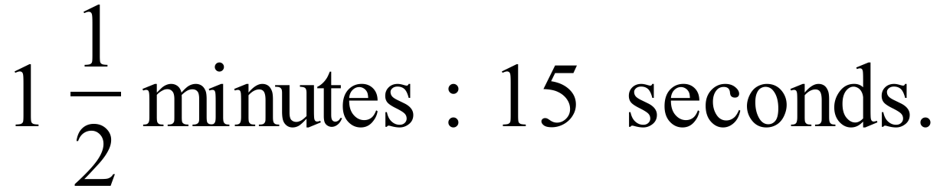

……………………………………………………………………………………………….

……………………………………………………………………………………………….
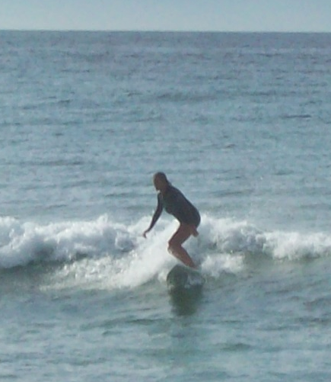
When Freida walked along the beach she counted the number of people on surfboards and surf skis.
The ratio of surfboards to surf skis was 8 : 5.
There were 48 surfboard riders.
How many were on surf skis?

……………………………………………

…………………………………………….

……………………………………………
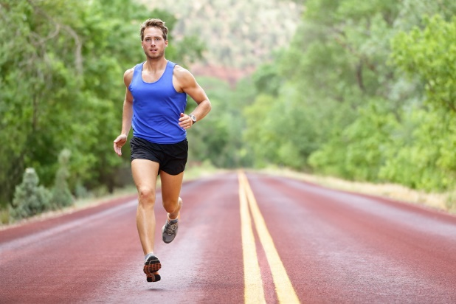
Adrian regularly runs 12 km in training for marathons.
His average speed is 5 m/s.
How many minutes would one of his training runs take?

……………………………………………

……………………………………………

…………………………………………….

……………………………………………
Simplify the ratio 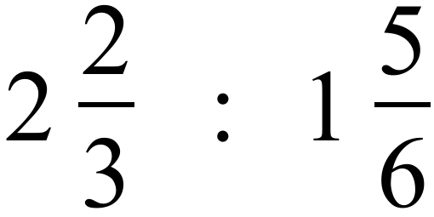

……………………………………………………………………………………………….

……………………………………………………………………………………………….
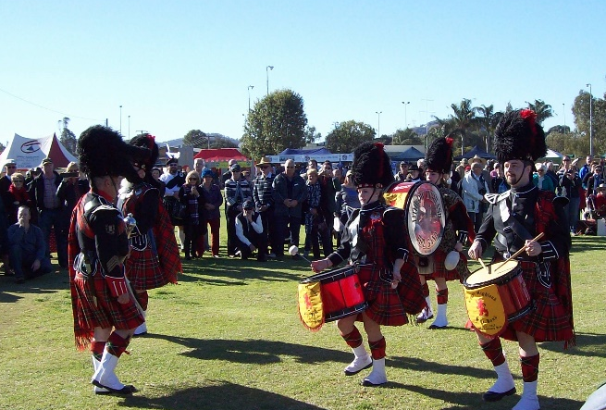
The ratio of pipers : drummers : spectators at a highland band competition was 5 : 7 : 18.
The pipers and drummers together added up to 360 people.
How many spectators were there?

……………………………………………

……………………………………………

…………………………………………….

……………………………………………
To mix a paint, Pablo uses Cyan : Magenta : Yellow in the ratio 5 : 3 : 2. He has plenty of paint to mix except for only having 6 ml of yellow remaining. What is the largest amount of paint he could make?

……………………………………………………………………………………………….

……………………………………………………………………………………………….
Aimee, Brad and Cathy divide 360 toffees between them in the ratio 4 : 3 : 2. How many more toffees than Brad, does Aimee get?

……………………………………………………………………………………………….

……………………………………………………………………………………………….
Convert 2 ml per second into litres per hour.

……………………………………………………………………………………………….

……………………………………………………………………………………………….
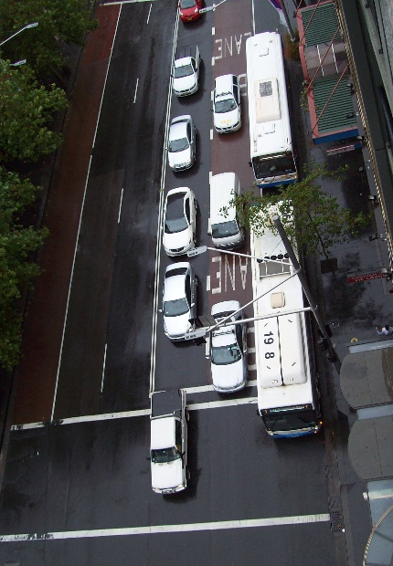
A city intersection has an average of 360 vehicles/hour pass through it.
Jim sits down at the intersection at 9 am, to complete a survey by observing the vehicles passing through.
What time would he finish if he needs to observe 2100 vehicles?

……………………………………………

……………………………………………

…………………………………………….

……………………………………………

Year 9 |  | Ratio and Rates | Calculator Allowed
 |  | Ratio and Rates | Name_________________
Section 2 Multiple Choice Section
Mark all your answers on the accompanying multiple choice answer sheet, not on this test paper. You may do any working out on this test paper. Calculators are allowed for this section.

A radio station plays 18 rock tracks and 24 hip hop tracks in a three hour program. What is the ratio of rock to hip hop tracks, in simplest form?

A. 3 : 4 B. 4 : 3 C. 3 : 7 D. 4 : 7

The ratio of green to red jelly beans in a pack is 2 : 3.
If there are 60 jelly beans in the pack, how many are red?

A. 12 B. 24 C. 36 D. 48

The ratio of pens to pencils in a drawer is 5 : 2.
If there are 24 pencils, how many pens are there?

A. 12 B. 24 C. 48 D. 60

Kelly checks her heart rate after a run. She counts 36 beats in 30 seconds. What is her heart rate?

A. 18 beats/minute B. 36 beats/minute
C. 54 beats/minute D. 72 beats/minute

An engine makes 3 000 revolutions/minute (rpm). How many revolutions would it make in 6½ minutes?

A. 18 500 B. 19 500 C. 21 000 D. 24 000

A garden has 24 m² of paths, 48 m² of garden beds and 144 m² of lawn.
What is the ratio of paths to the rest of the garden?

A. 1 : 2 B. 1 : 4 C. 1 : 6 D. 1 : 8

What is the ratio of the times they take to complete the run?

A. 3 : 2 B. 2 : 5 C. 3 : 5 D. 5 : 6

Holly went to a presentation where the ratio of adults to school students was 3 : 4. There were 120 adults at the presentation. How many people were at the presentation?

A. 240 B. 280 C. 320 D. 540

A plane flies at a groundspeed of 620 km/h.
How long would a flight which is 2 015 km take?

A. 3 hours exactly B. 3 hours and 15 minutes

C. 3 hours and 25 minutes D. 3 hours and 30 minutes

The cost of a single padded post bag is $1.20.
They can also be bought in a bulk pack of 100 for $52.00.
How much per bag is saved by buying in a bulk pack?

A. $0.43 per bag B. $0.52 per bag C. $0.68 per bag D. $1.20 per bag

When 2.6 kg of chocolate is divided in the ratio 2 : 3 : 8, how much is the smallest portion?

A. 130 grams B. 250 grams C. 300 grams D. 400 grams
The ratio of boys to girls in a class was 3 : 4, before two boys and two girls were moved to another class, leaving 14 girls in the class. What is the new ratio of boys to girls in the class?

A. 5 : 6 B. 5 : 7 C. 5 : 12 D. 7 : 12

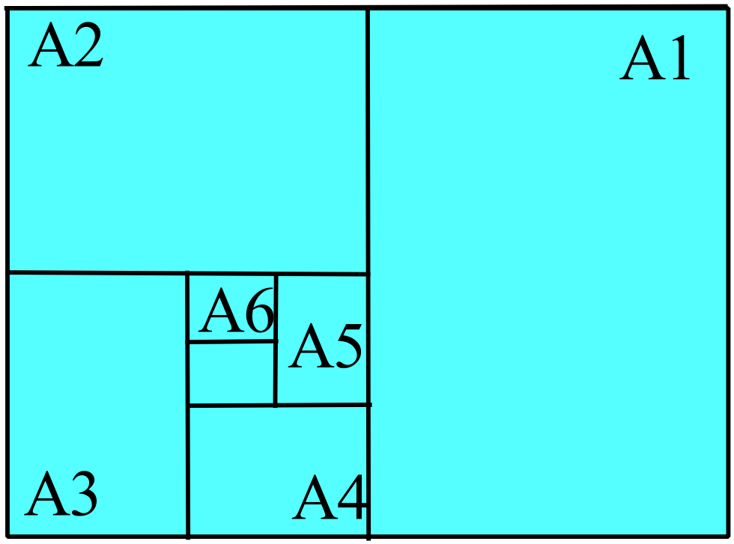An A0 sheet of paper is shown, divided into smaller paper sizes.
The A0 sheet is cut in half to form two
A1 sheets.
The A1 sheet is then cut in half to form two A2 sheets.
The A2 is cut in half to form two A3 sheets etc.

What is the ratio of the area of an A5 sheet to an A1 sheet?

- 1 : 4 B. 1 : 8

C. 1 : 16 D. 1 : 32

A car is travelling at 72 km/h along a road which has telephone poles spaced every 200 metres.
How long would it take the car to move from one pole to the next?

A. 10 seconds B. 15 seconds C. 20 seconds D. 30 seconds

Zahra and Ali work in a factory packing bottles of jam into boxes which hold 120 bottles.
Zahra can pack a box in 5 minutes and it takes Ali 6 minutes to pack the same box.
How long would it take them, working together to pack 55 boxes?

A. 2¼ hours B. 2⅓ hours C. 2½ hours D. 2¾ hours

Ratio and Rates

Multiple Choice Answer Sheet
Name _____________________________________________
Completely fill the response oval representing the most correct answer.

1. A B C D
2. A B C D
3. A B C D
4. A B C D
5. A B C D
6. A B C D
7. A B C D
8. A B C D
9. A B C D
10. A B C D
11. A B C D
12. A B C D
13. A B C D
14. A B C D
15. A B C D

Ratio and Rates

ANSWERS
Section 1 ( 1 mark each)
Working and Answers
Helicopters : Aeroplanes = 4 : 15.
20 : 35 = 4 : 7
Sedans : Hatchbacks = 40 : 24 = 5 : 3
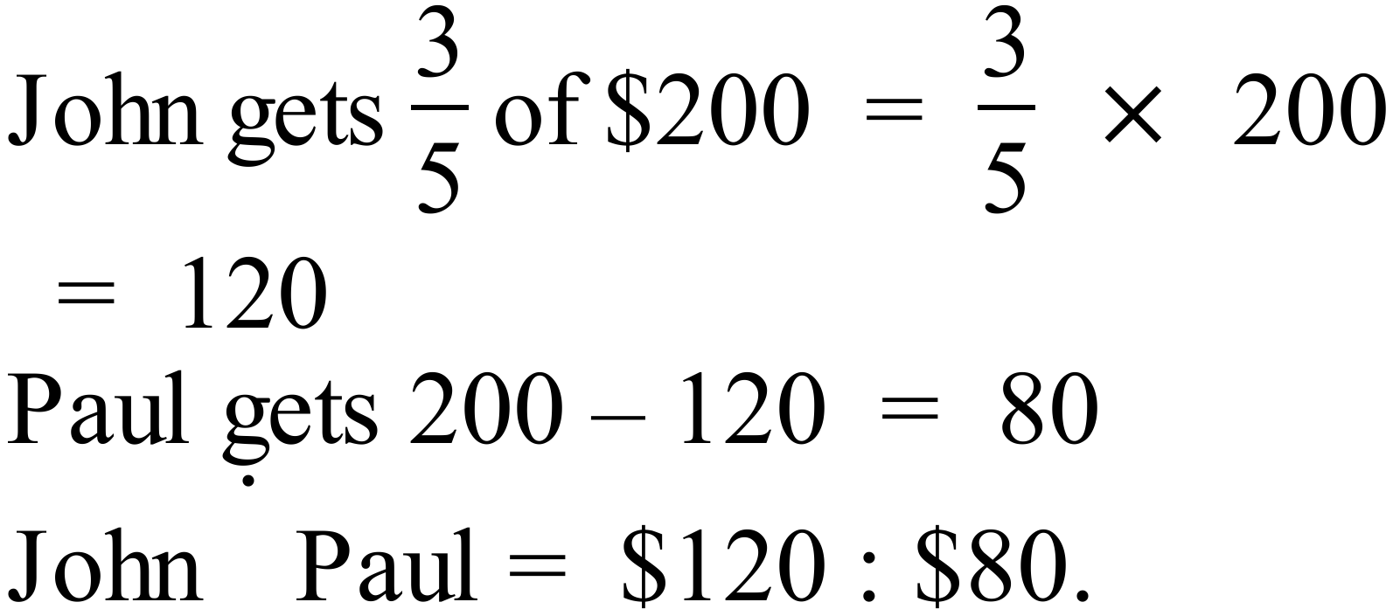
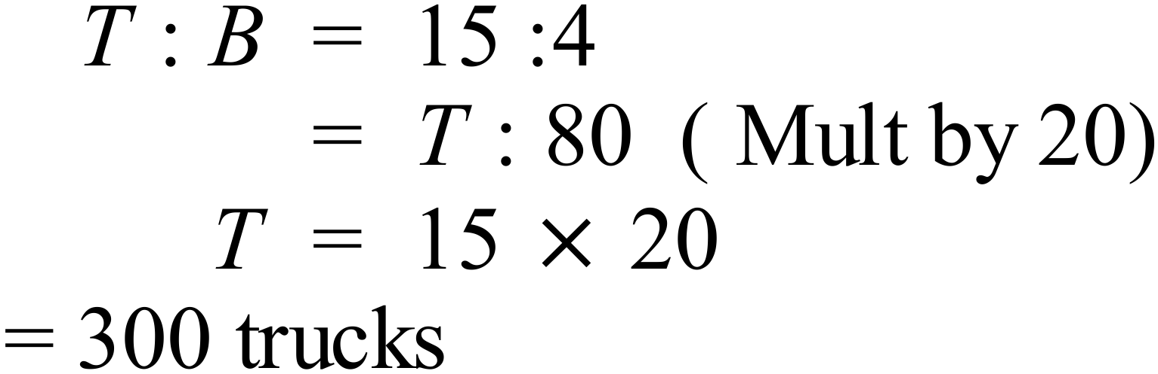
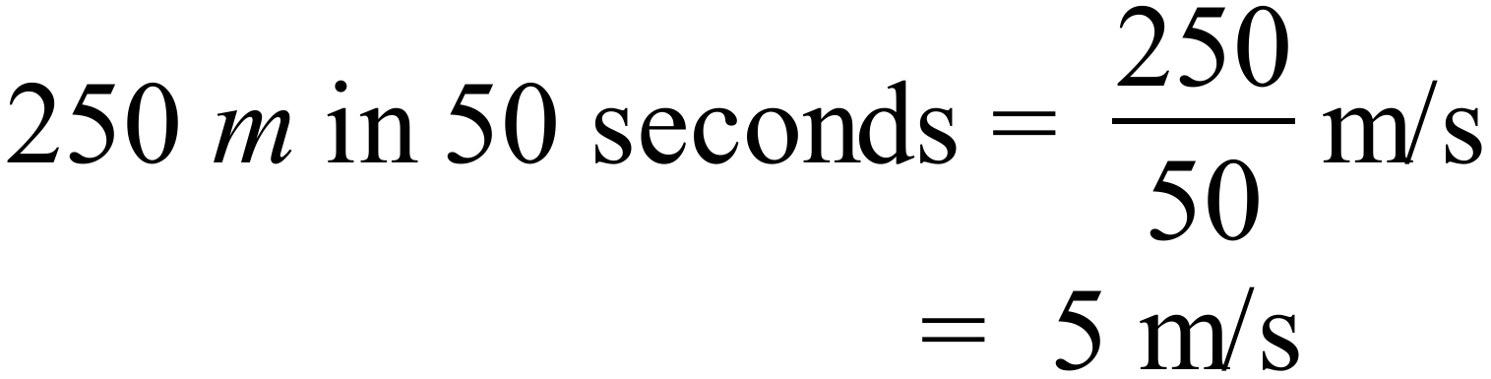
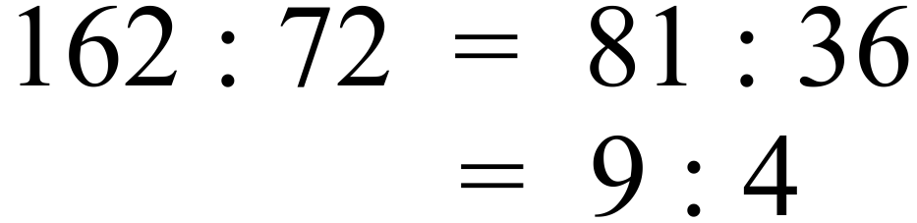
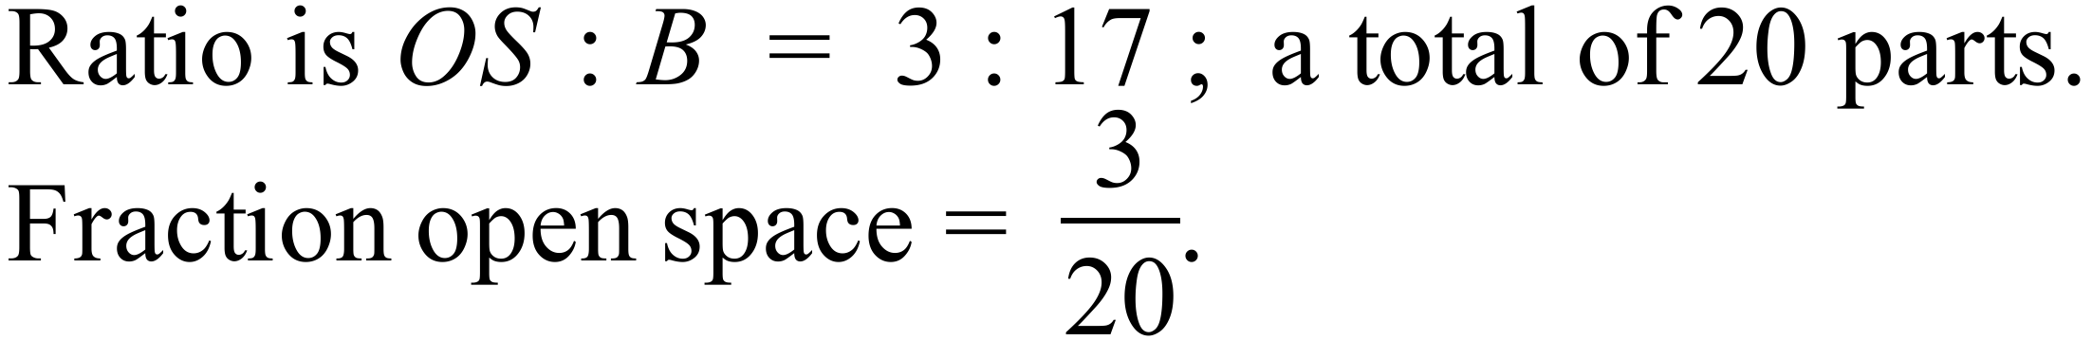
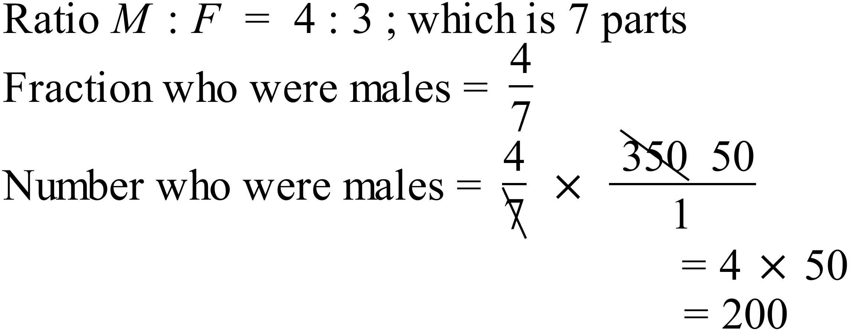males
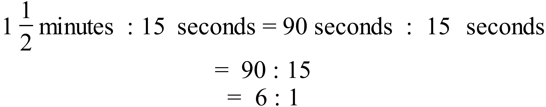
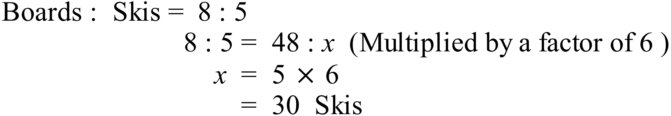
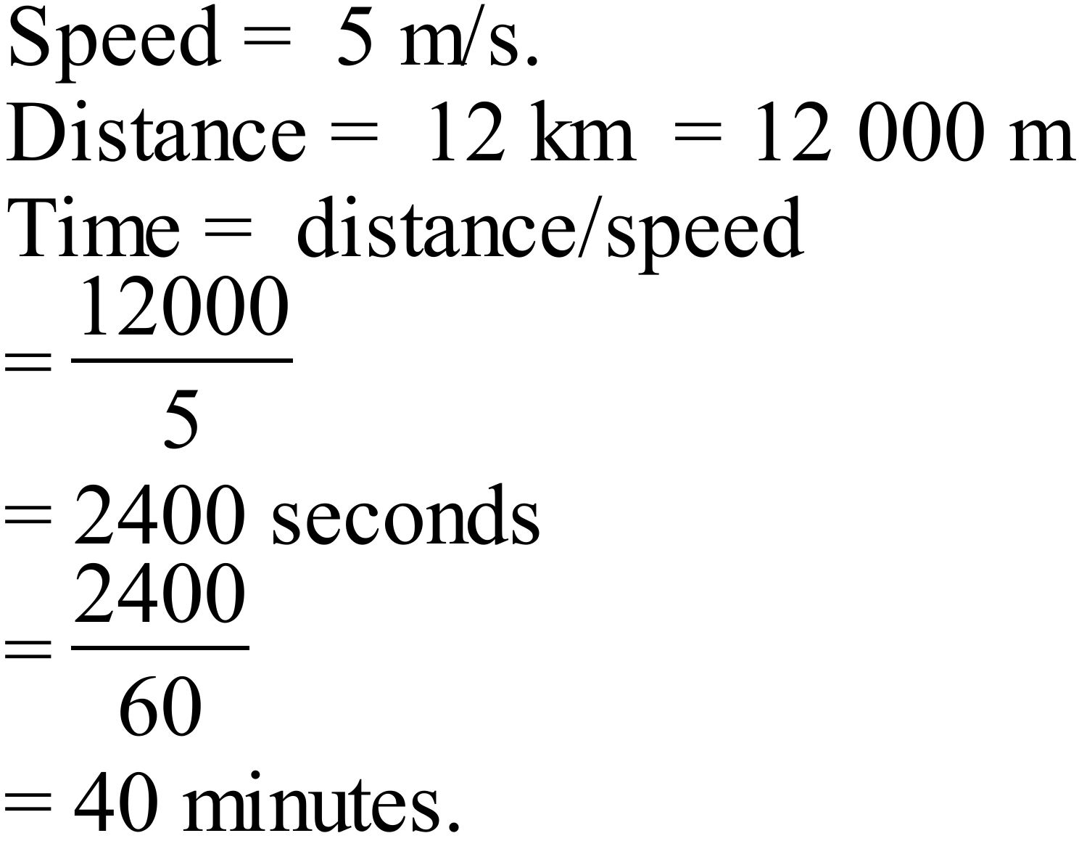
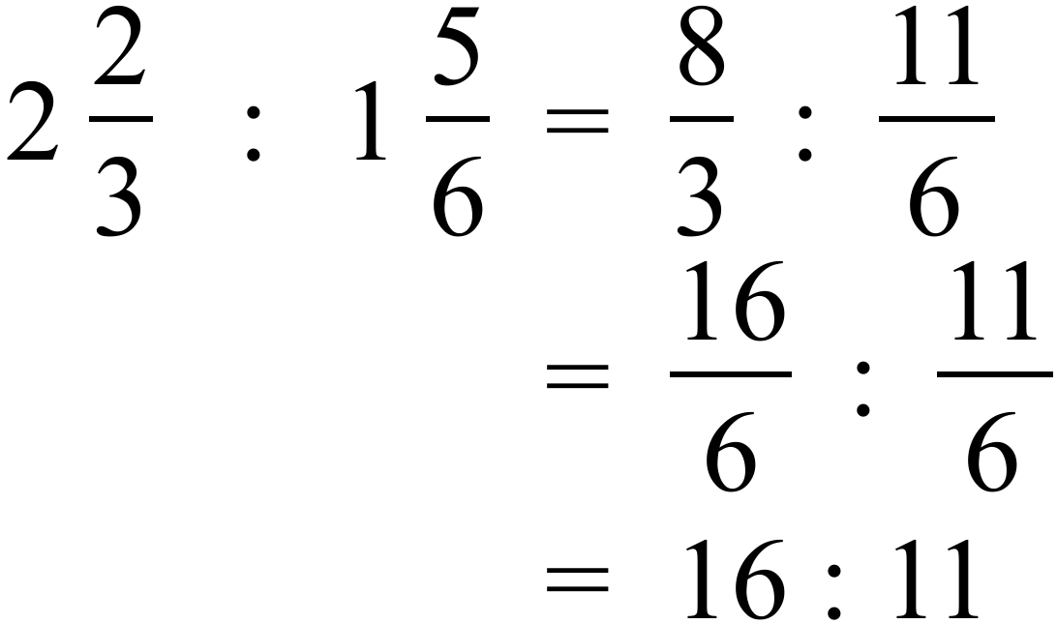
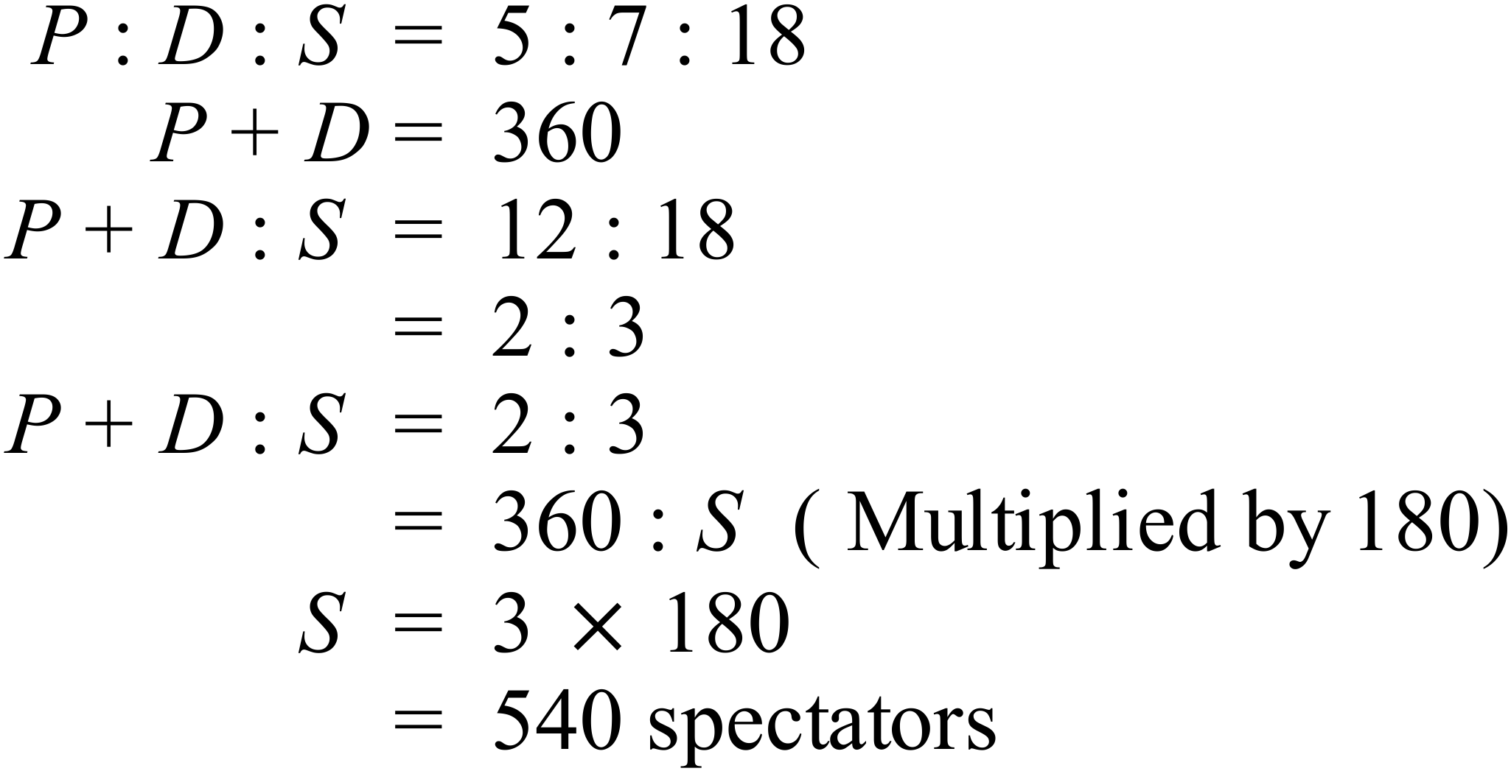
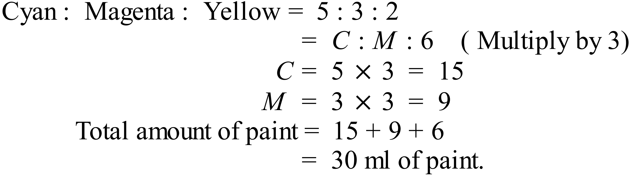
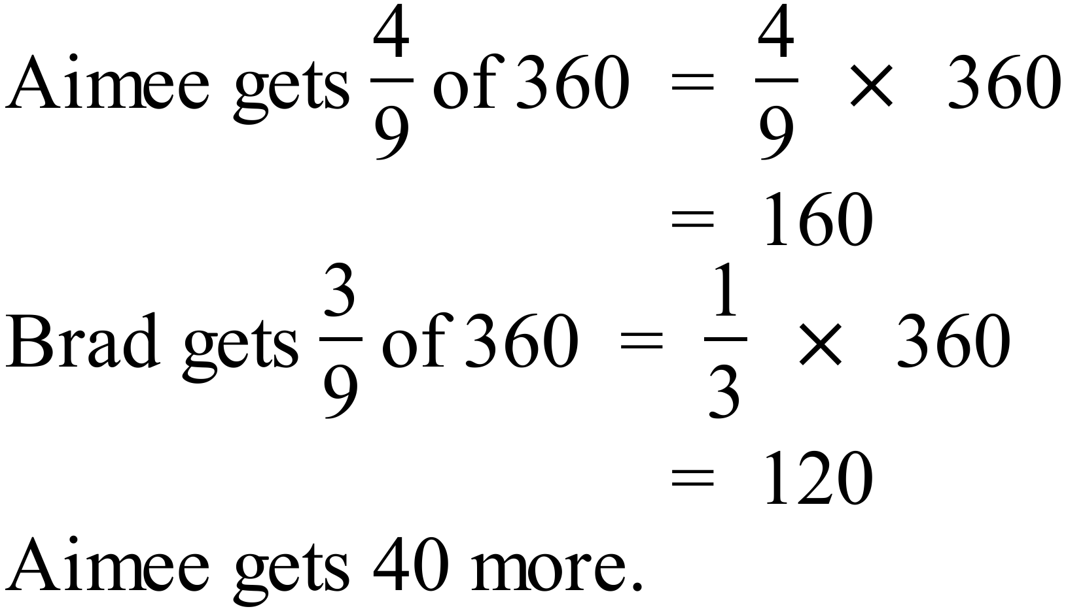
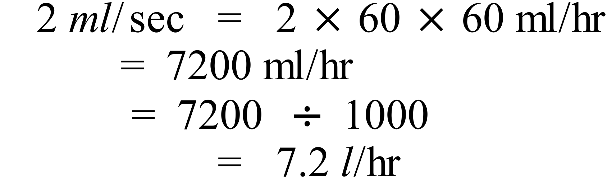
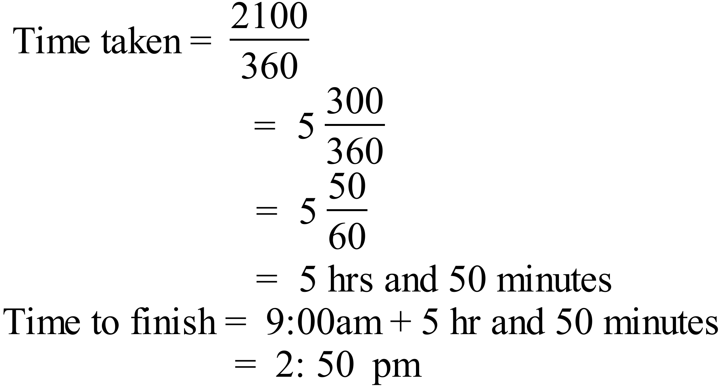

Section 2 (1 mark each)
 | Working | Answers
 | 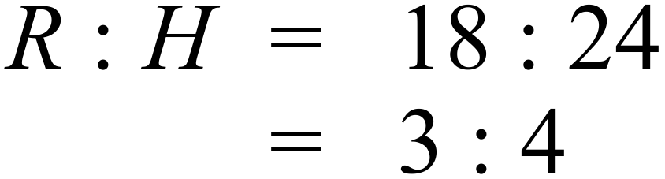 | A
 | 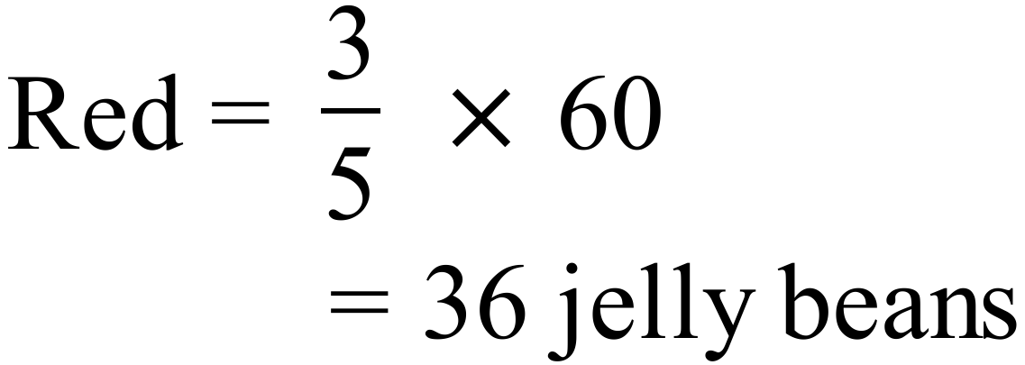 | C
 | 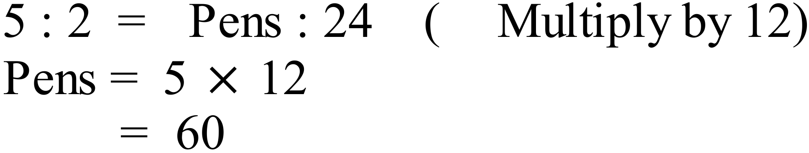 | D
 | 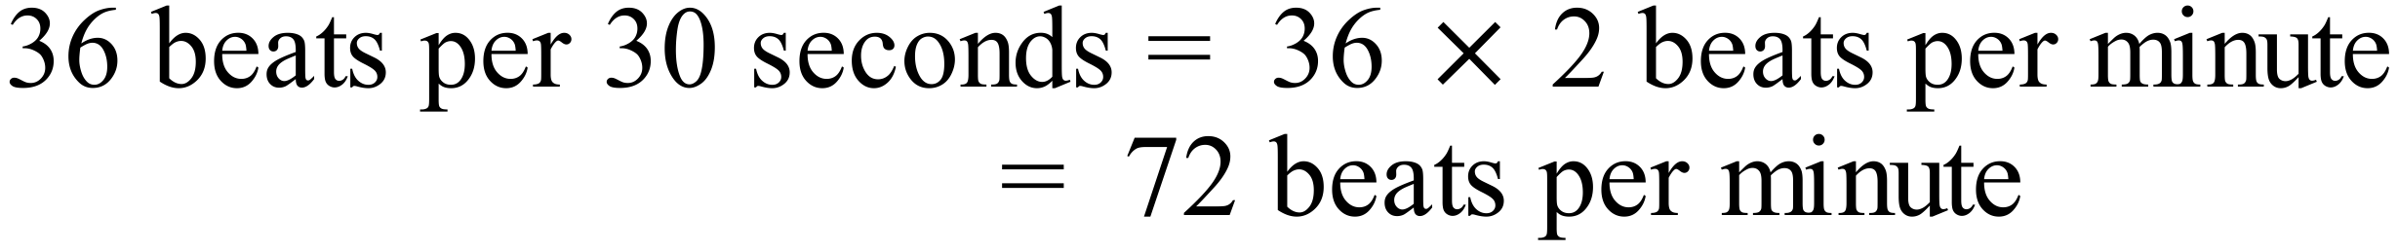 | D
 |  | B
 | 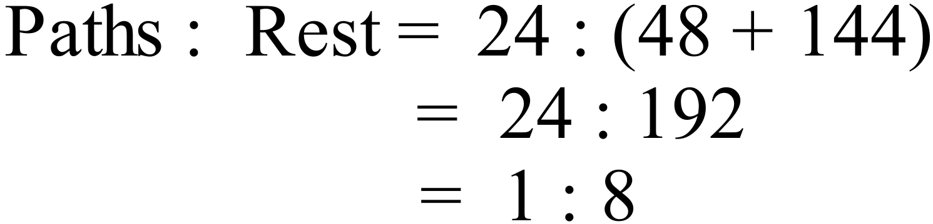 | D
 | 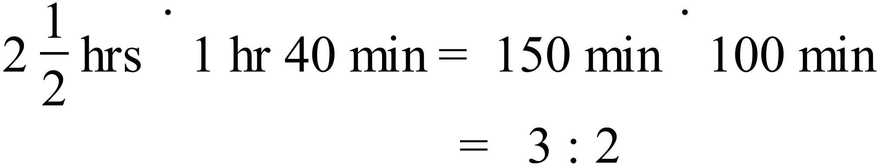 | A
 | 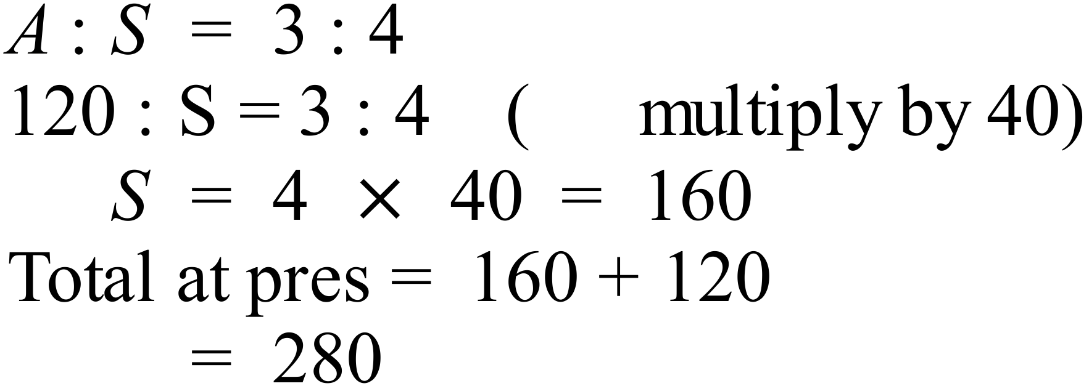 | B
 | 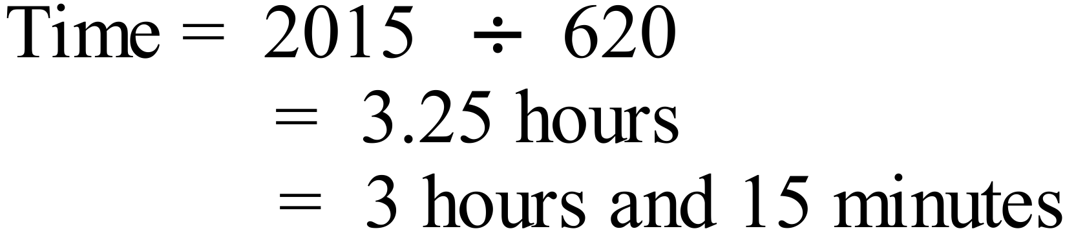 | B
 | 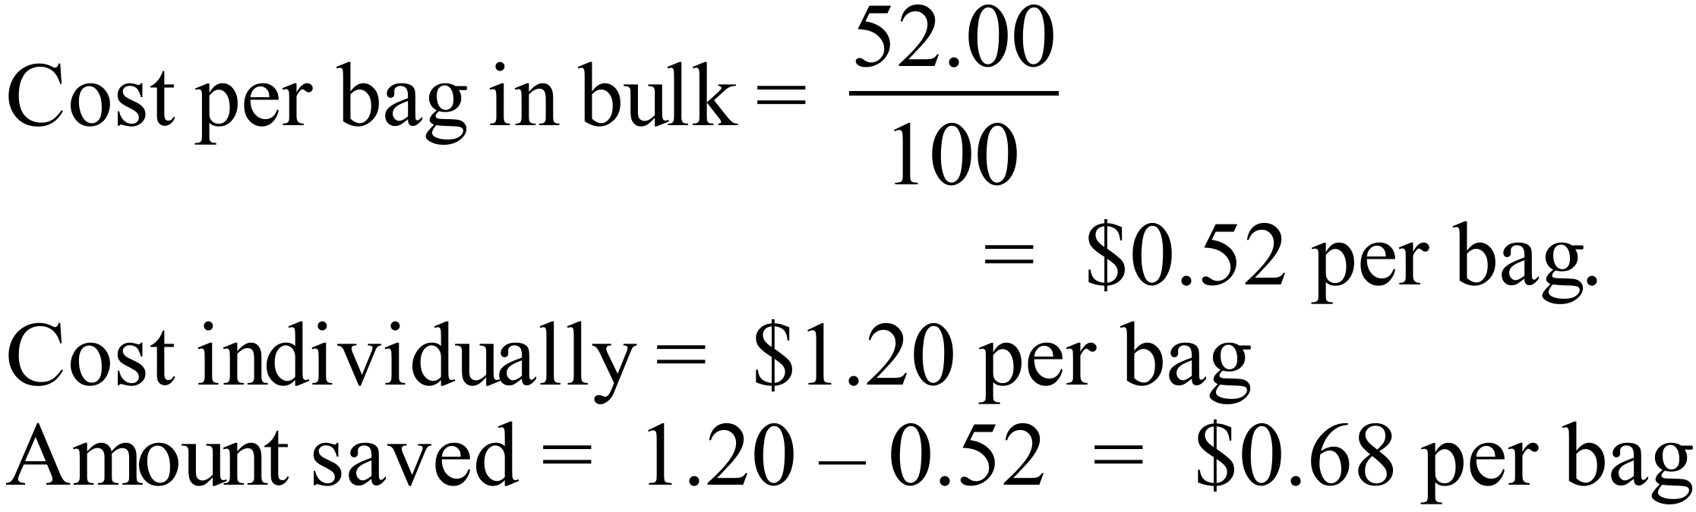 | C
 | 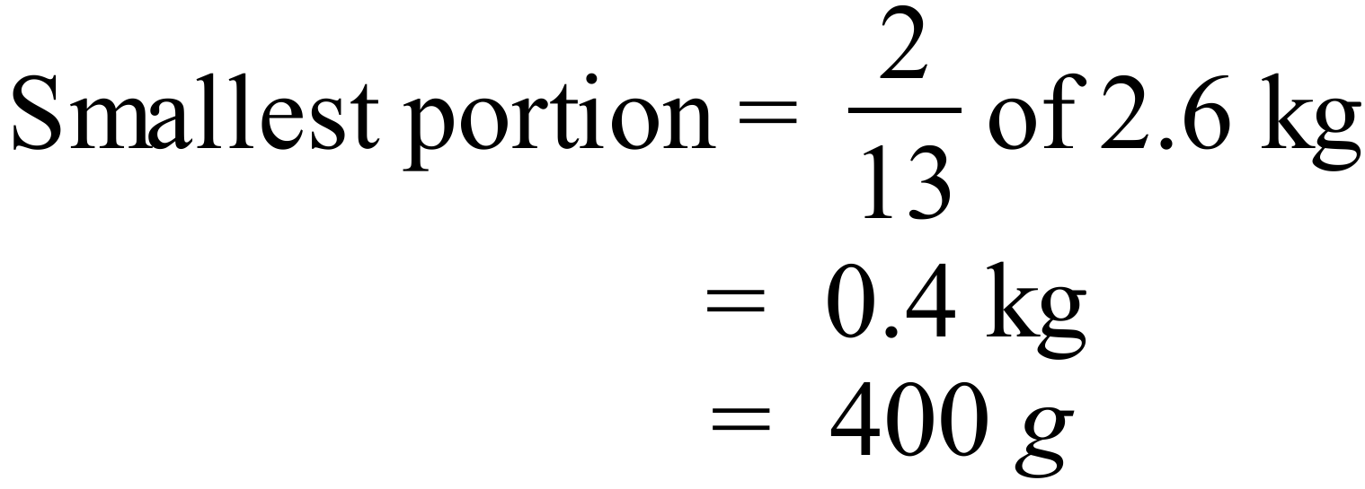 | D
 | There are now 14 girls, so previously there were 16.  Previous ratio was 3 : 4  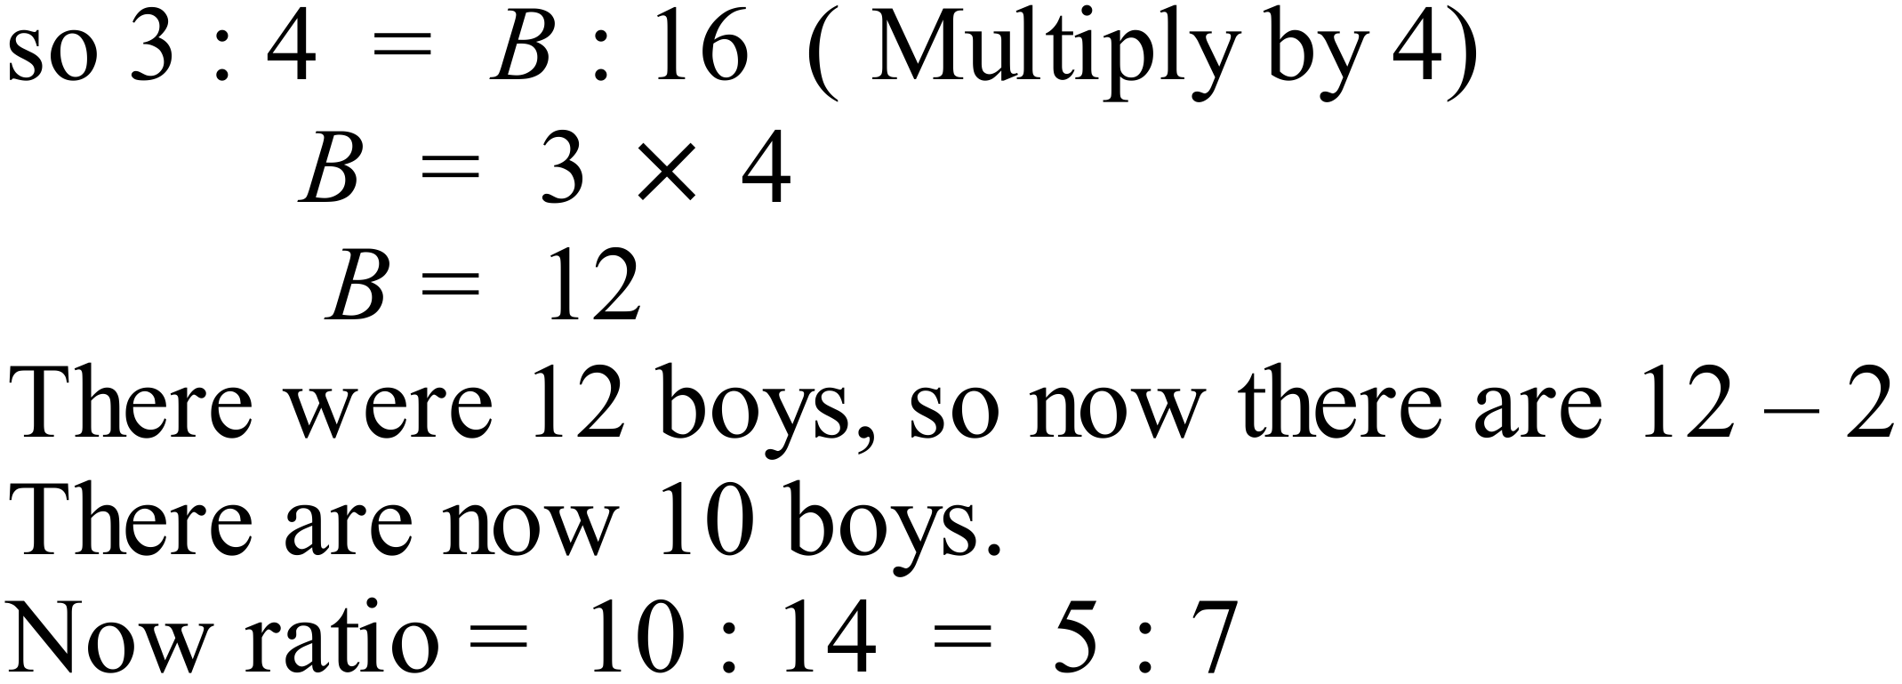 | B
 | There are 2 A5 in an A4, so 4 in an A3, 8 in an A2 and 16 in an A1.  Ratio is 1 : 16 | C
 | 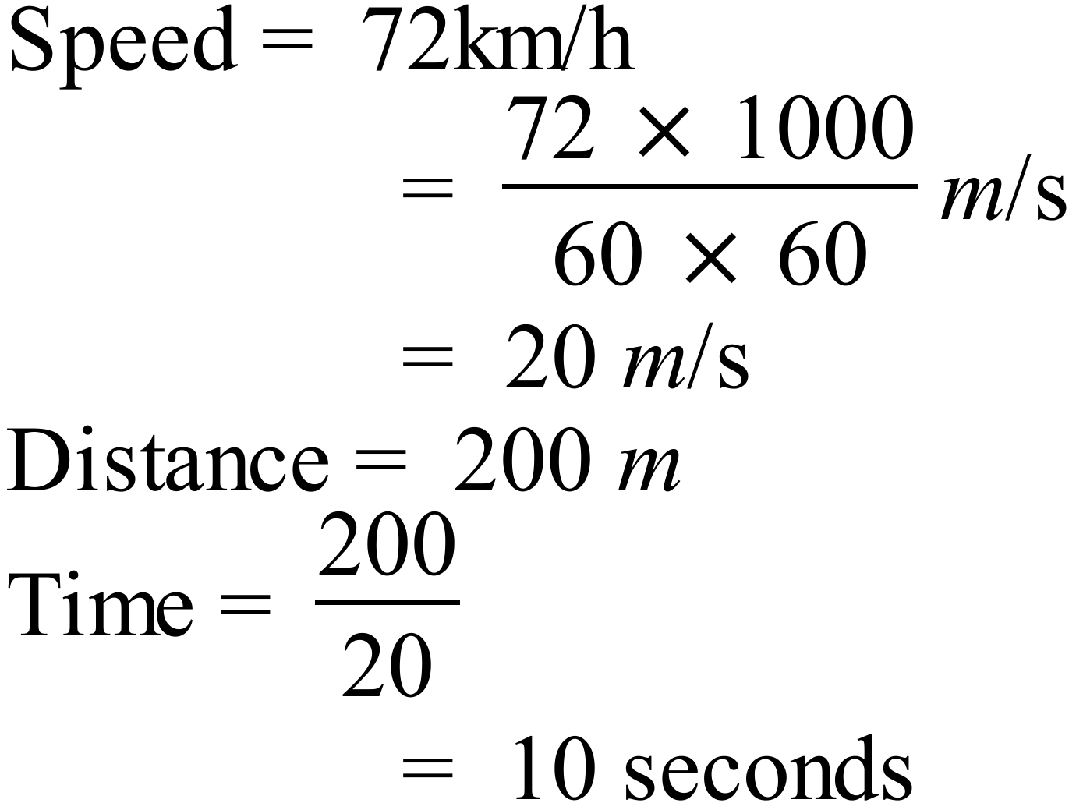 | A
 | In an hour, Zahra packs 12 boxes and Ali packs 10 boxes, so together they pack 22 boxes per hour.  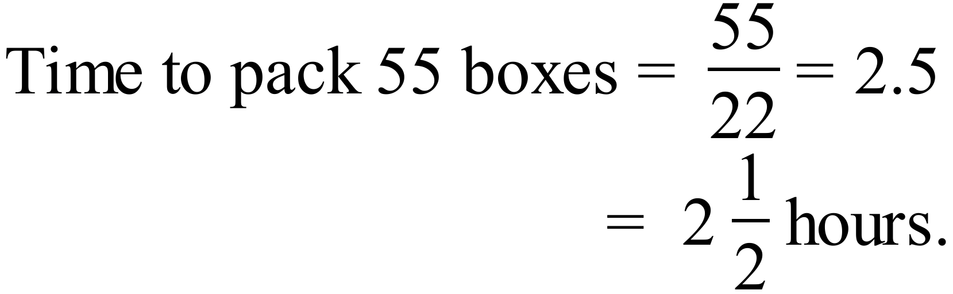 | C

Ratio and Rates

Multiple Choice Answer Sheet
Name ___ Marking Sheet
Completely fill the response oval representing the most correct answer.

1. A B C D
2. A B C D
3. A B C D
4. A B C D
5. A B C D
6. A B C D
7. A B C D
8. A B C D
9. A B C D
10. A B C D
11. A B C D
12. A B C D
13. A B C D
14. A B C D
15. A B C D

